A Minor Project Synopsis on

**Emotion Classification of Hinglish Social Media Text**

Submitted to Manipal University, Jaipur

Towards the partial fulfillment for the Award of the Degree of

**BACHELOR OF TECHNOLOGY**

In Information Technology

2020-2021

By

Siddhant Bhanot (189402111)

Sagar Rajput (189303154)



Under the guidance of

Mr. Ankit Mundra

**Department of Information Technology**

**School of Computing and Information Technology**

**Manipal University Jaipur**

**Jaipur, Rajasthan**

# Introduction

The aim of this project is to classify the emotion of a given hinglish social media text using supervised machine learning algorithms.

The emotion of the given text can be classified into different categories such as anger, fear, happy, disgust, etc.

# Motivation

In many cases it is required to know the emotion of a given text. For example,

* The understanding of the emotion of a review given by a consumer.
* Finding how happy a country’s citizens are for research purposes (World Happiness Report)
* Can be used by recommender systems for giving relevant suggestions to consumer based on the emotion of the review given by the consumer.

In all these cases and many more, an ML model can be used to classify the emotions for a given hinglish text.

With this project, we aim to make the ML model which will classify the emotion of the provided hinglish text.

# Project Objective

The project archives to classify the emotion of a given hinglish text using ML techniques in acceptable time.

Until now only binary sentiment analysis was done on a given text using ML which would classify the text into positive or negative without considering the deeper analysis of the human emotion or sensitivities in the given text and the only option for emotion classification would be to do it manually.

# Methodology

The methodology for the given project is as follows

1. Collection of hinglish text data
2. Labelling the data
3. Cleaning up of the data
4. Defining the ML model
5. Training ML model
6. Testing ML model
7. Model deployment

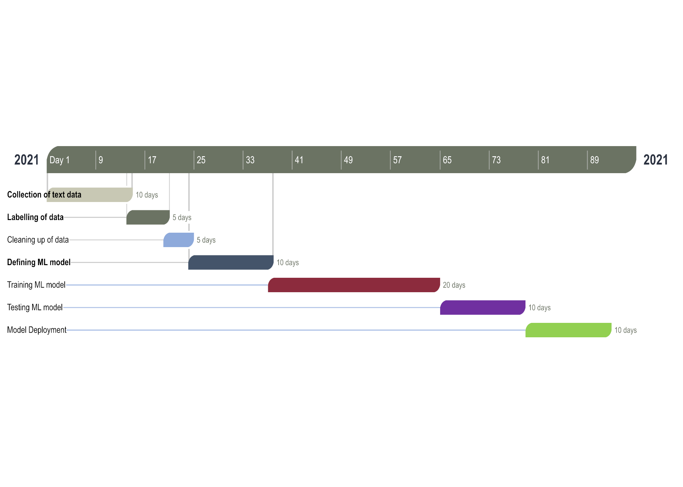

# Facilities required for proposed project

Software requirements

1. Pandas
2. NumPy
3. TensorFlow
4. Scikit-learn

# References